**Logistic regression:**



Logistic regression is used when we have a problem in which we need to classify the variable y.

To attempt classification, one method is to use linear regression and map all predictions greater than 0.5 as a 1 and all less than 0.5 as a 0. However, this method doesn't work well because classification is not actually a linear function.

For eg: if we say that all the people who have malignant tumor as classified as 1 and all those who have a benign tumor as classified as 0.

Now we will try to solve this problem linear regression:

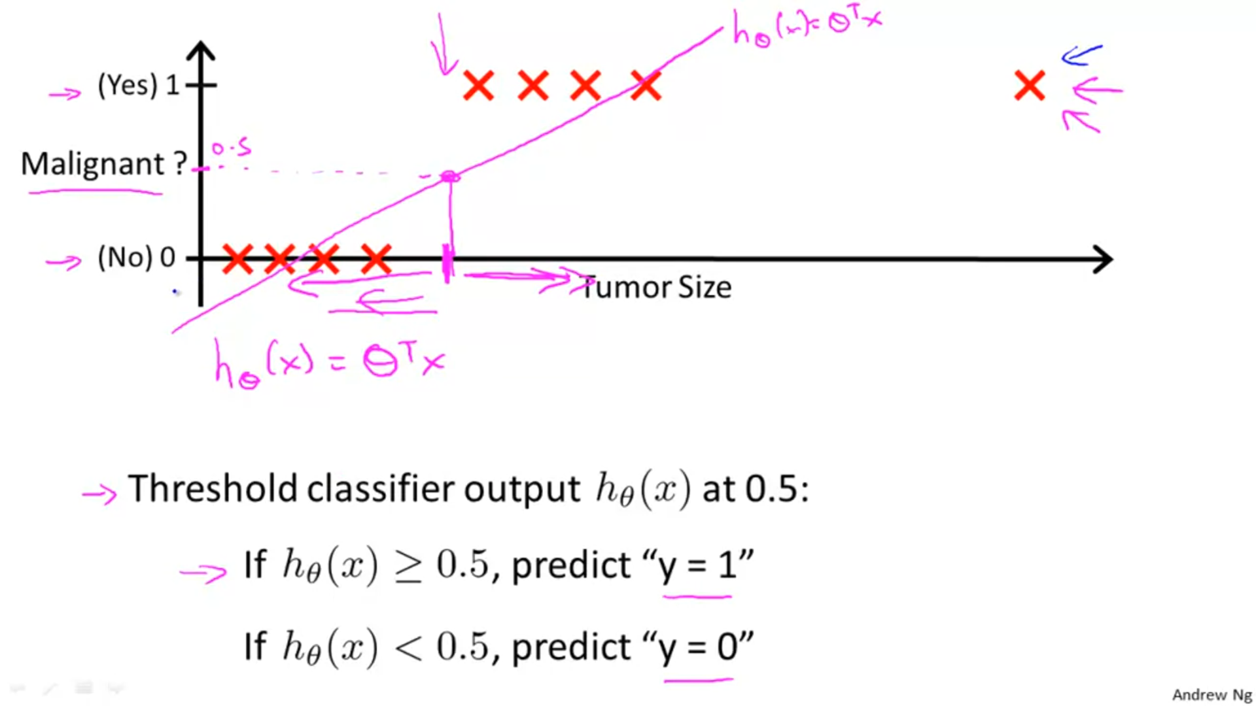



Now, suppose we add a point A in the graph:





Now due to this point A , what would happen is that the line will bend more towards the axis, and a new regression line will be created:

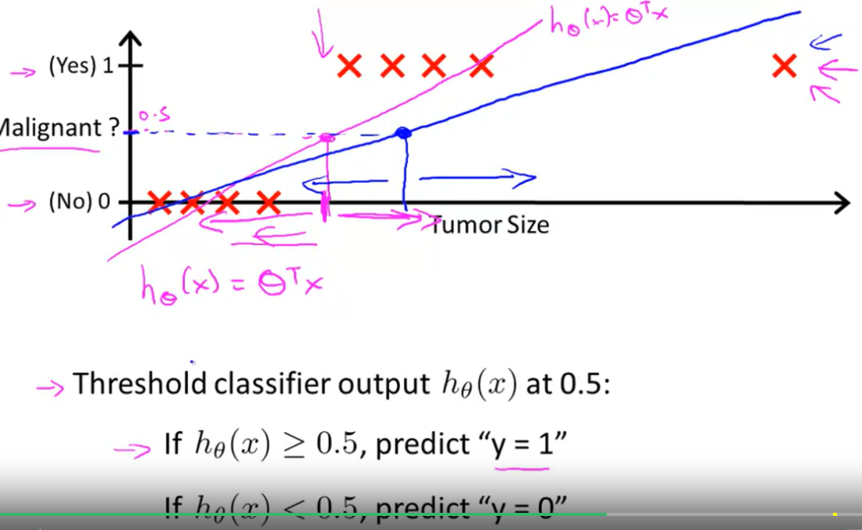

The new line also has the same criteria for classifying points as malignant and benign i.e. :

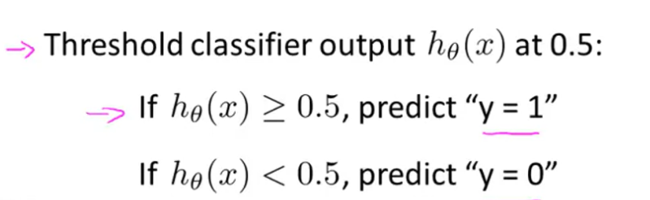

But, what happens is that points B and C which were earlier classified as malignant are tunow benign since the values of tumor predicted by them are <0.5 . This has caused an error in our model.

Another thing that can happen is that though we want of our hypothesis to be 0 or 1 , our hypothesis may predict values of y to be greater than 1 or less than 0.

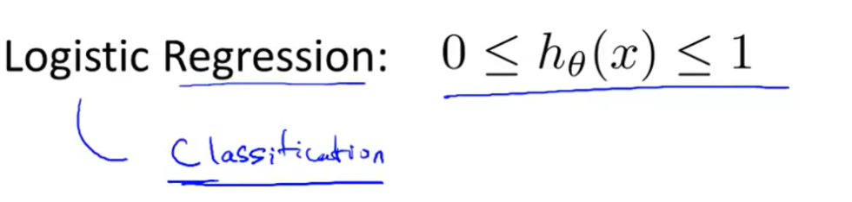

**The logistic regression model:**



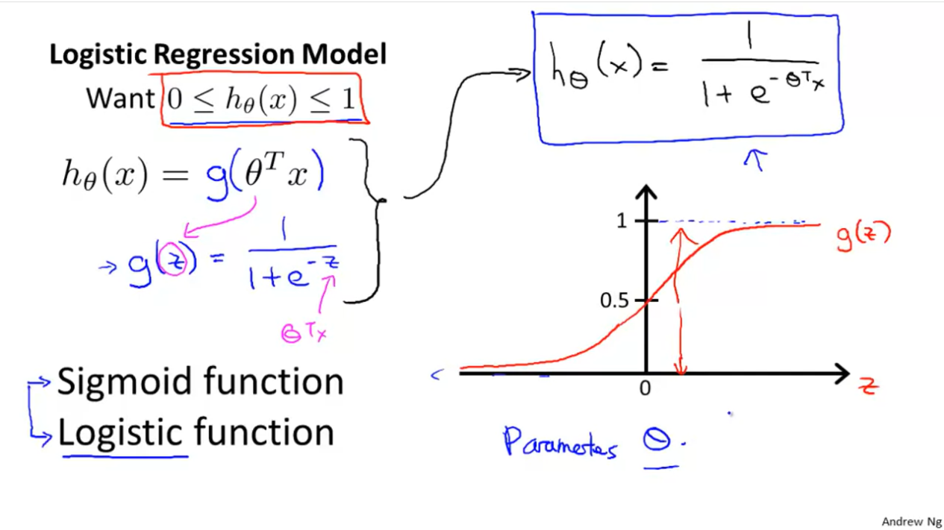

**Example of sigmoid function in R:**

sigmoid = function(x) {

1 / (1 + exp(-x))

}

plot(x,sigmoid(x))

x <- seq(-5, 5, 0.01)

plot(x,sigmoid(x),col='blue')

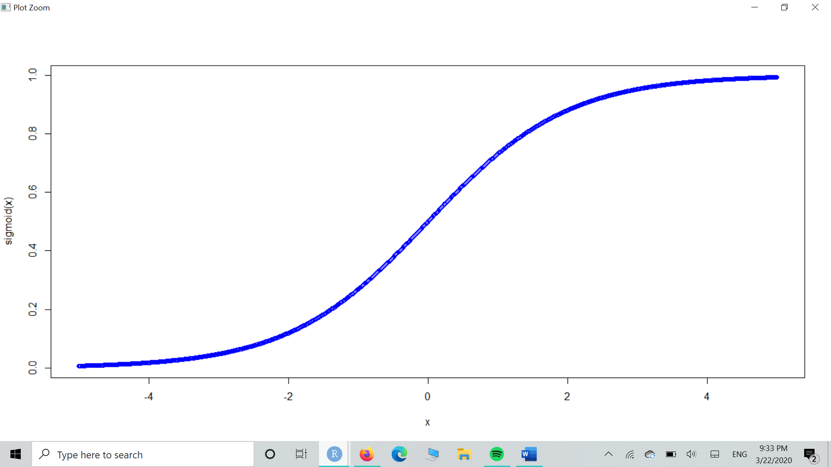

x <- seq(1,50)

plot(x,sigmoid(x),col=’blue’)

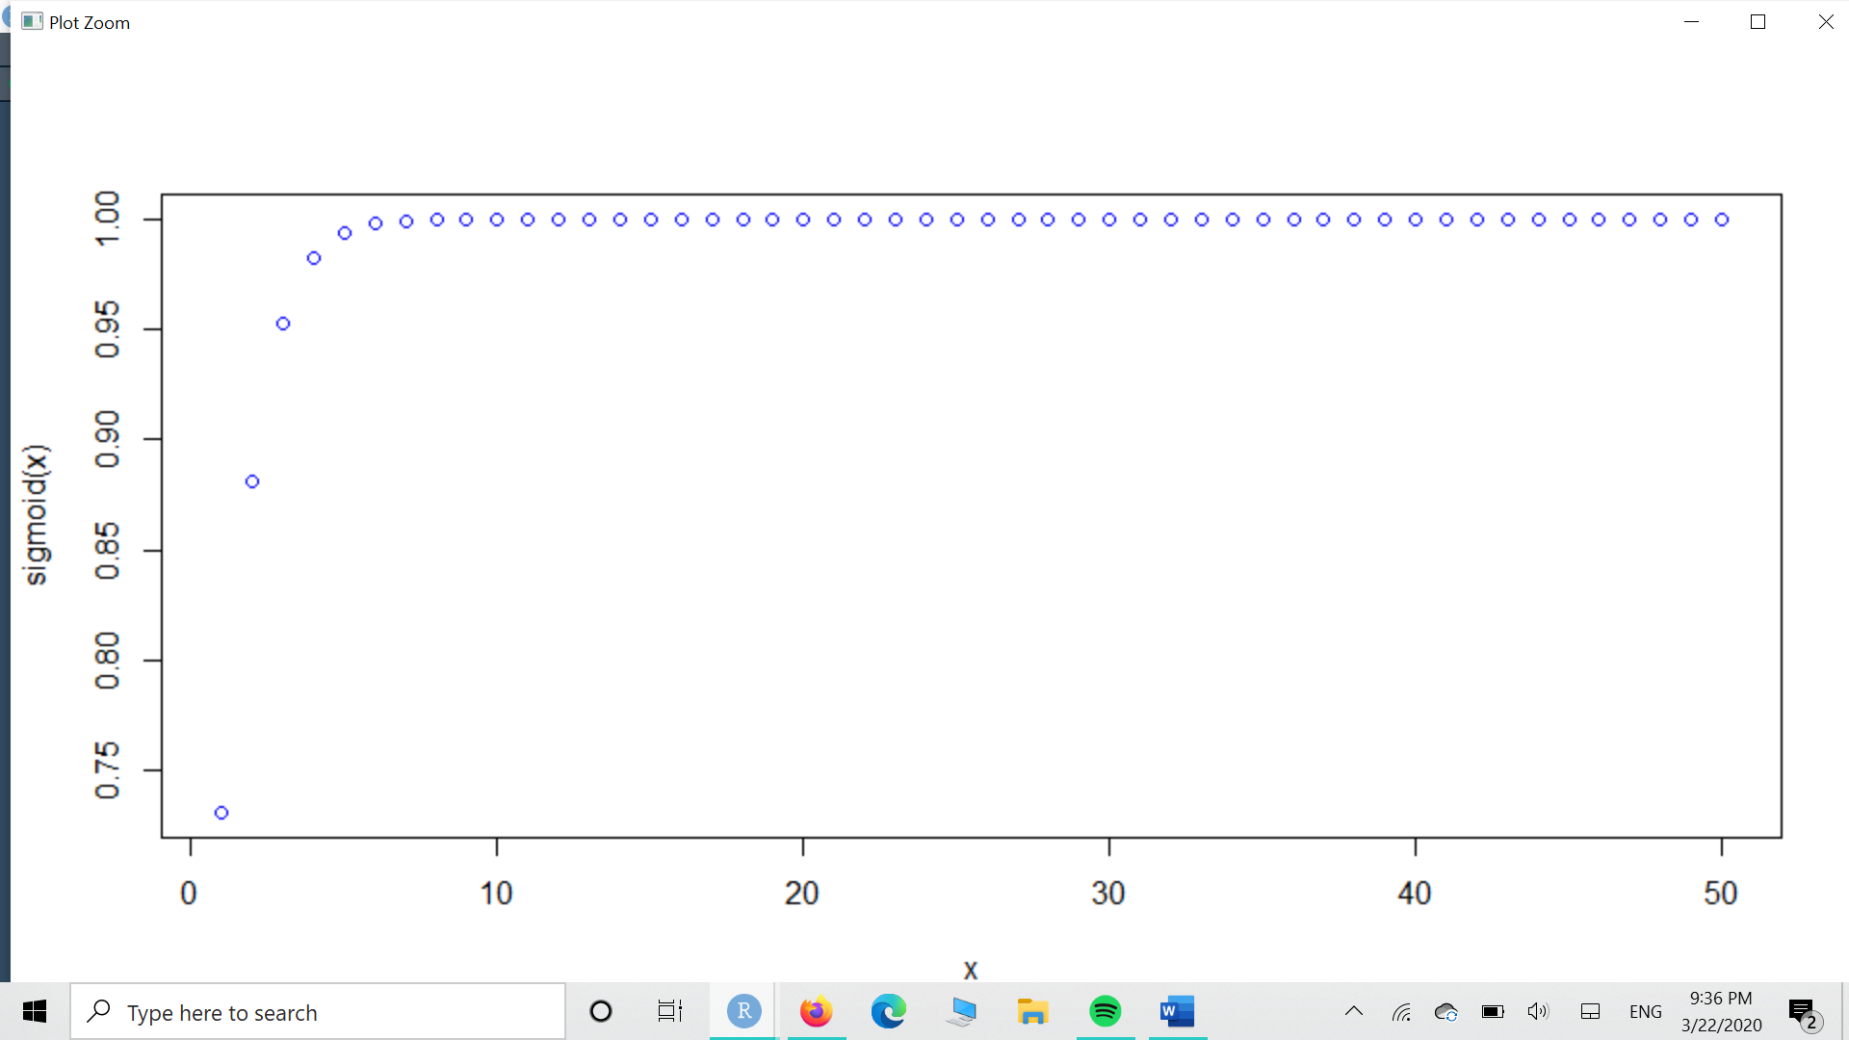

sigmoid(x)

[1] 0.7310586 0.8807971 0.9525741 0.9820138 0.9933071 0.9975274 0.9990889 0.9996646

[9] 0.9998766 0.9999546 0.9999833 0.9999939 0.9999977 0.9999992 0.9999997 0.9999999

[17] 1.0000000 1.0000000 1.0000000 1.0000000 1.0000000 1.0000000 1.0000000 1.0000000

[25] 1.0000000 1.0000000 1.0000000 1.0000000 1.0000000 1.0000000 1.0000000 1.0000000

[33] 1.0000000 1.0000000 1.0000000 1.0000000 1.0000000 1.0000000 1.0000000 1.0000000

[41] 1.0000000 1.0000000 1.0000000 1.0000000 1.0000000 1.0000000 1.0000000 1.0000000

[49] 1.0000000 1.0000000

exp(-20)

[1] 2.061154e-09

We see that as values of x keep on increasing , e-x keeps on becoming close to 0 and 1+ e-x keeps getting close to 1, hence we see many 1’s on the above plot.

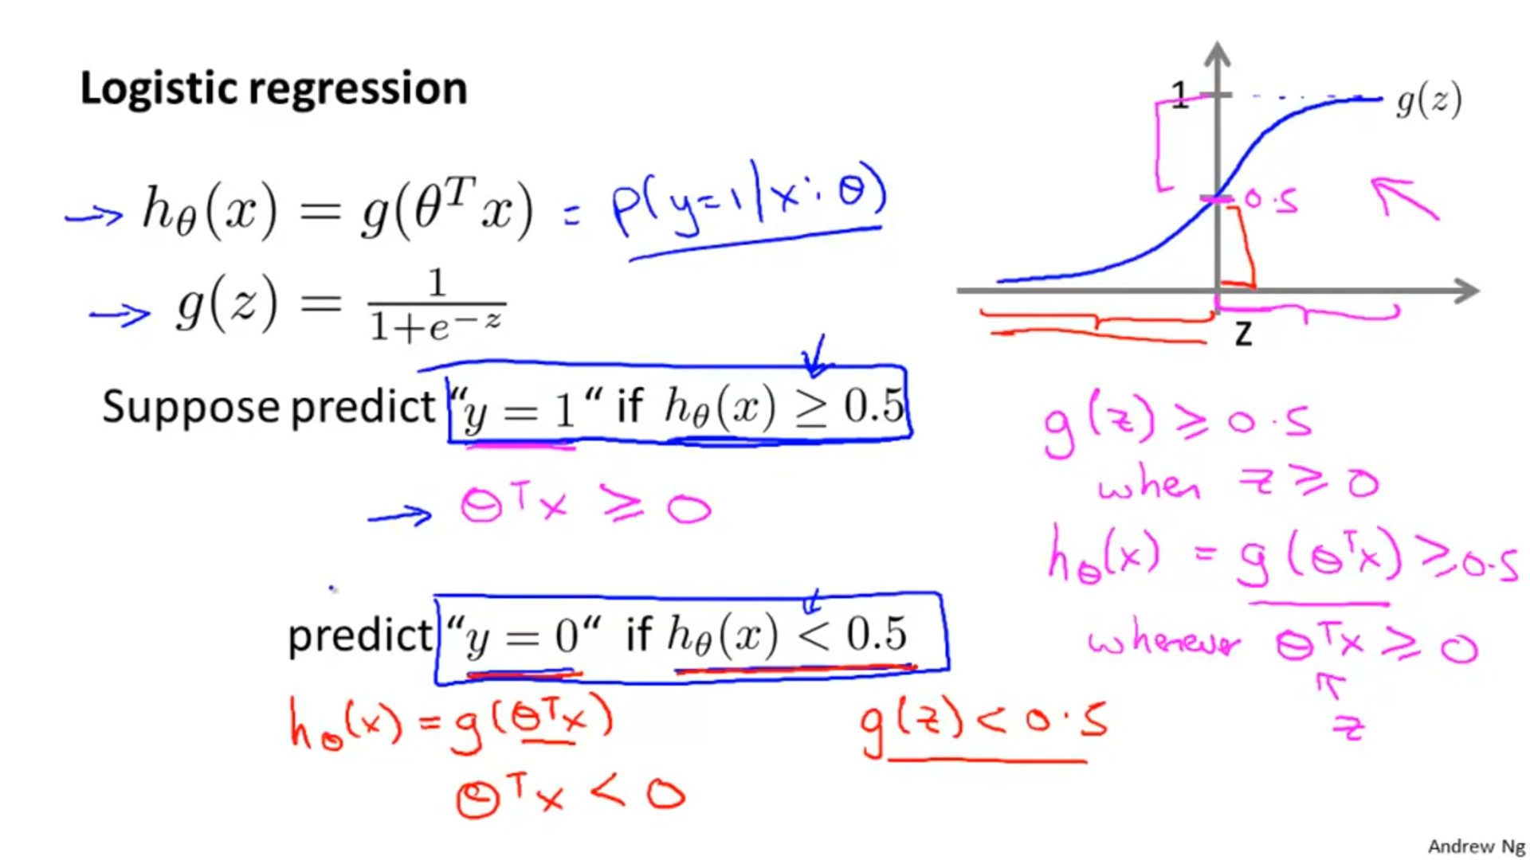

Examples predicting the above:

sigmoid(-0.23) ##z<=0 , which => probability of being close to 1 is low.

[1] 0.4427521

sigmoid(0.3) ##z>=0 , which => probability of being close to 1 is low.

[1] 0.5744425

sigmoid(0.82) ##z>=0 , which => probability of being close to 1 is low.

[1] 0.6942363

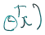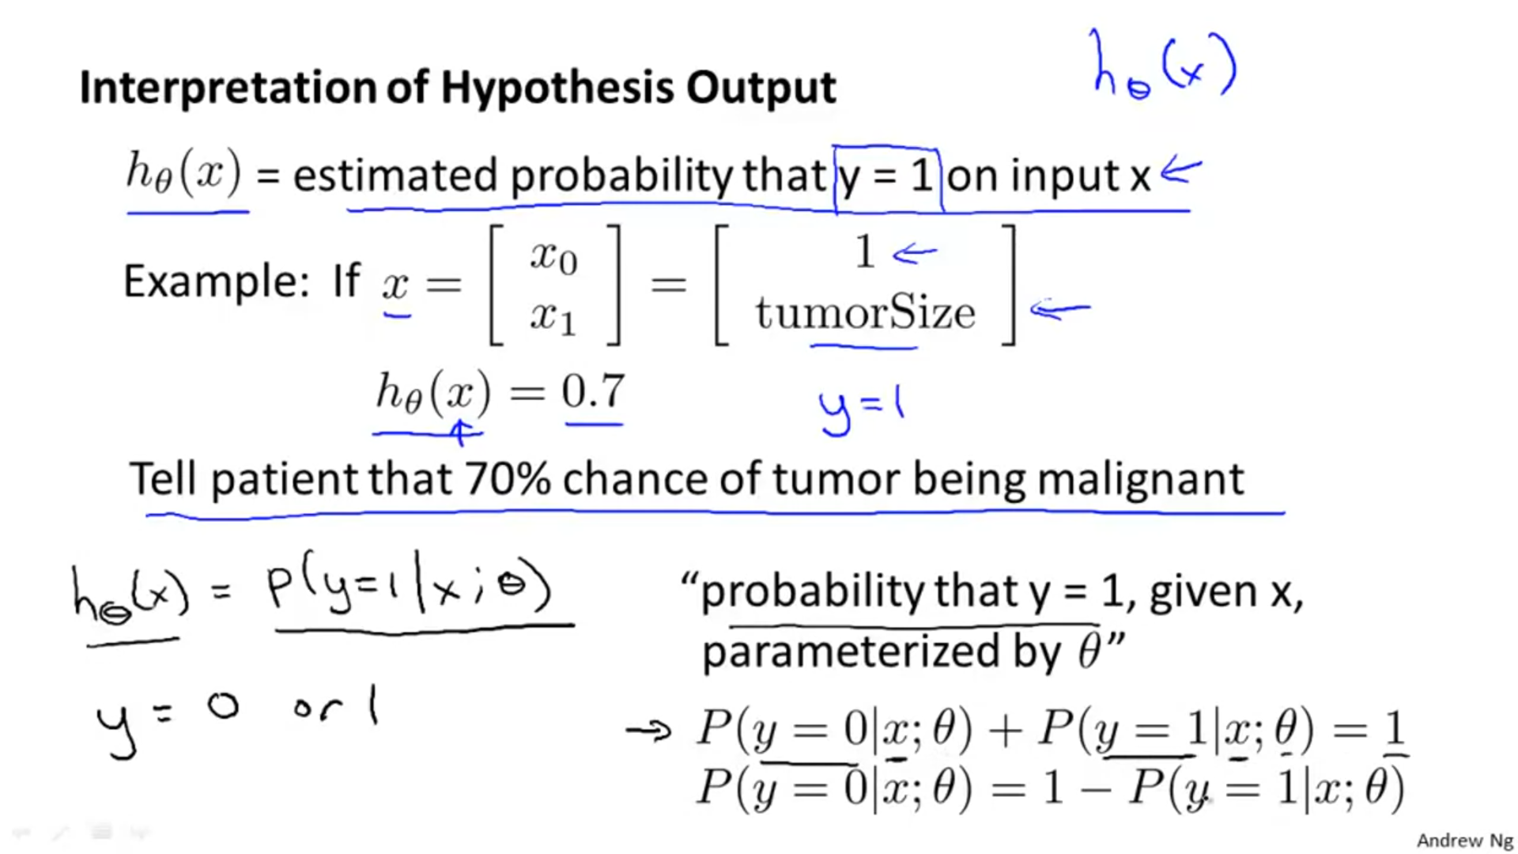



**DECISION BOUNDARY:**



**Example 1:**

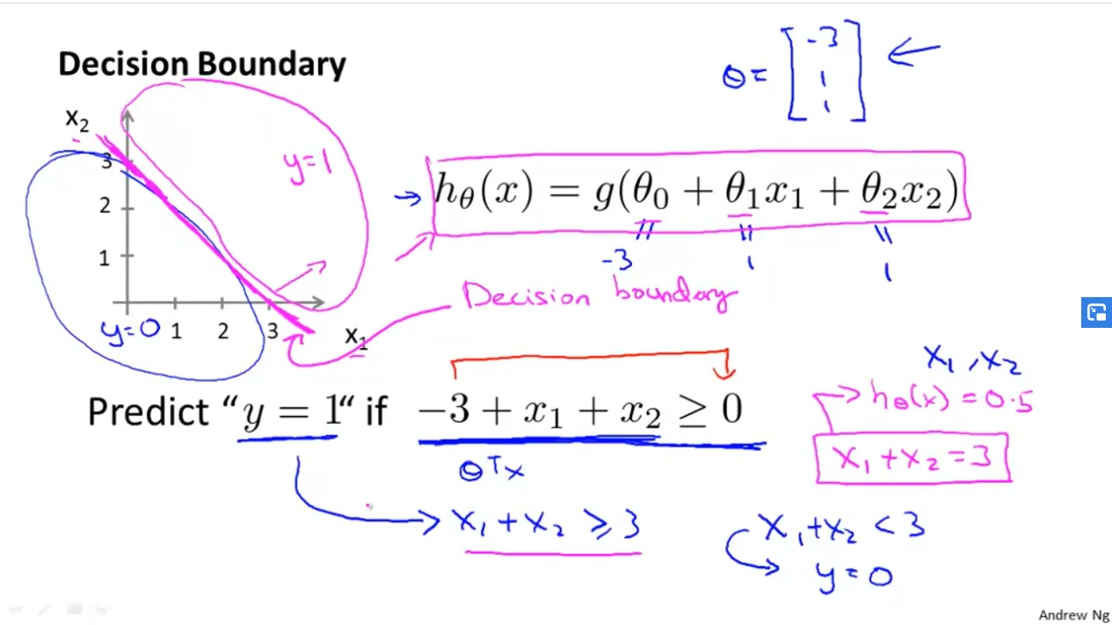





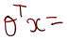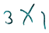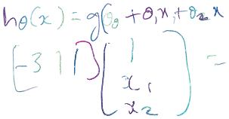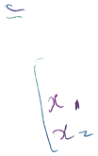



## The **decision boundary** is the line that separates the area where y = 0 and where y = 1. It is created by our hypothesis function.

Decision boundary gives us a way to segregate values which when fitted into logistic regression equation will have a probability of giving y =1 and y=0. In the above equation, values for which x1 + x2 >= 3 will have a greater probability of giving y=1.

Note: the decision boundary is a property of the hypothesis i.e. the decision boundary is made using the equation obtained from variables in the hypothesis equation , and not by seeing how the data/training set looks on the graph.

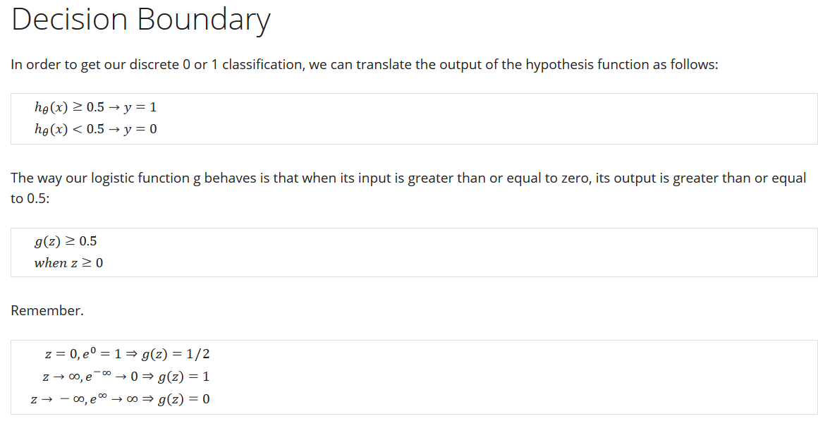

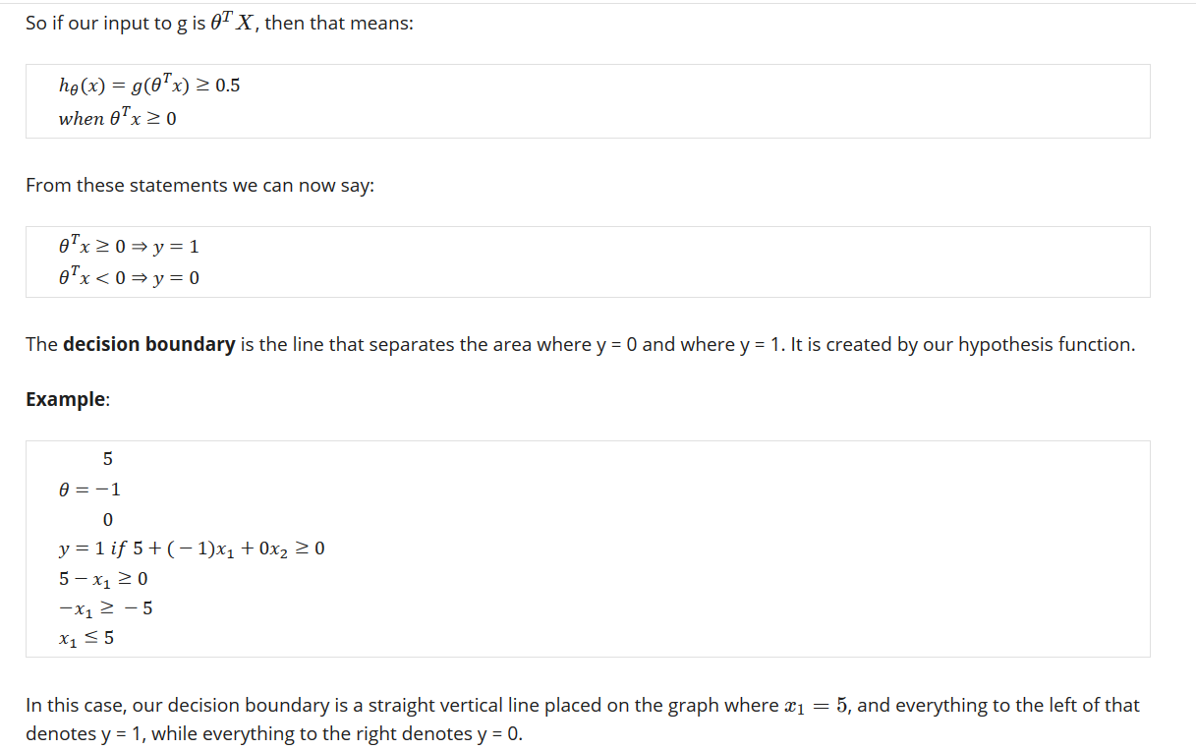

NOTE: 

Example 2:

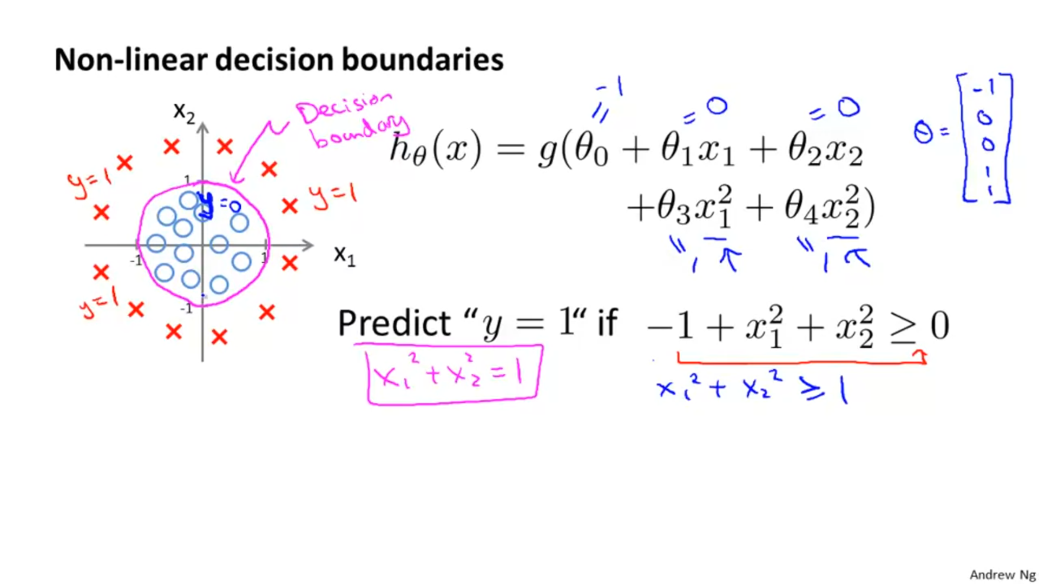

In the above plot, the decision boundary is not made by seeing how the training set/ data looks on the graph but it is made by using the hypothesis equation. Even if we had a plain graph like this:



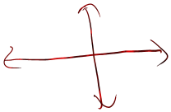

We could still plot a decision boundary using the equation of hypothesis x12 + x22 >=1:

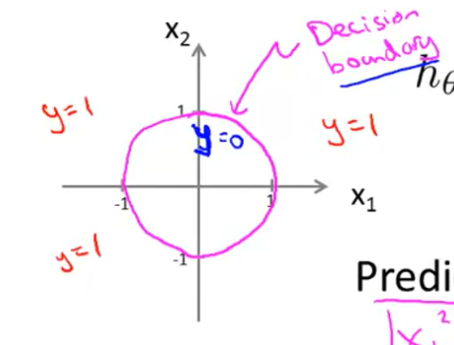



**Cost Function For Logistic Regression:**

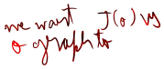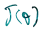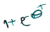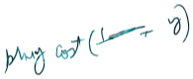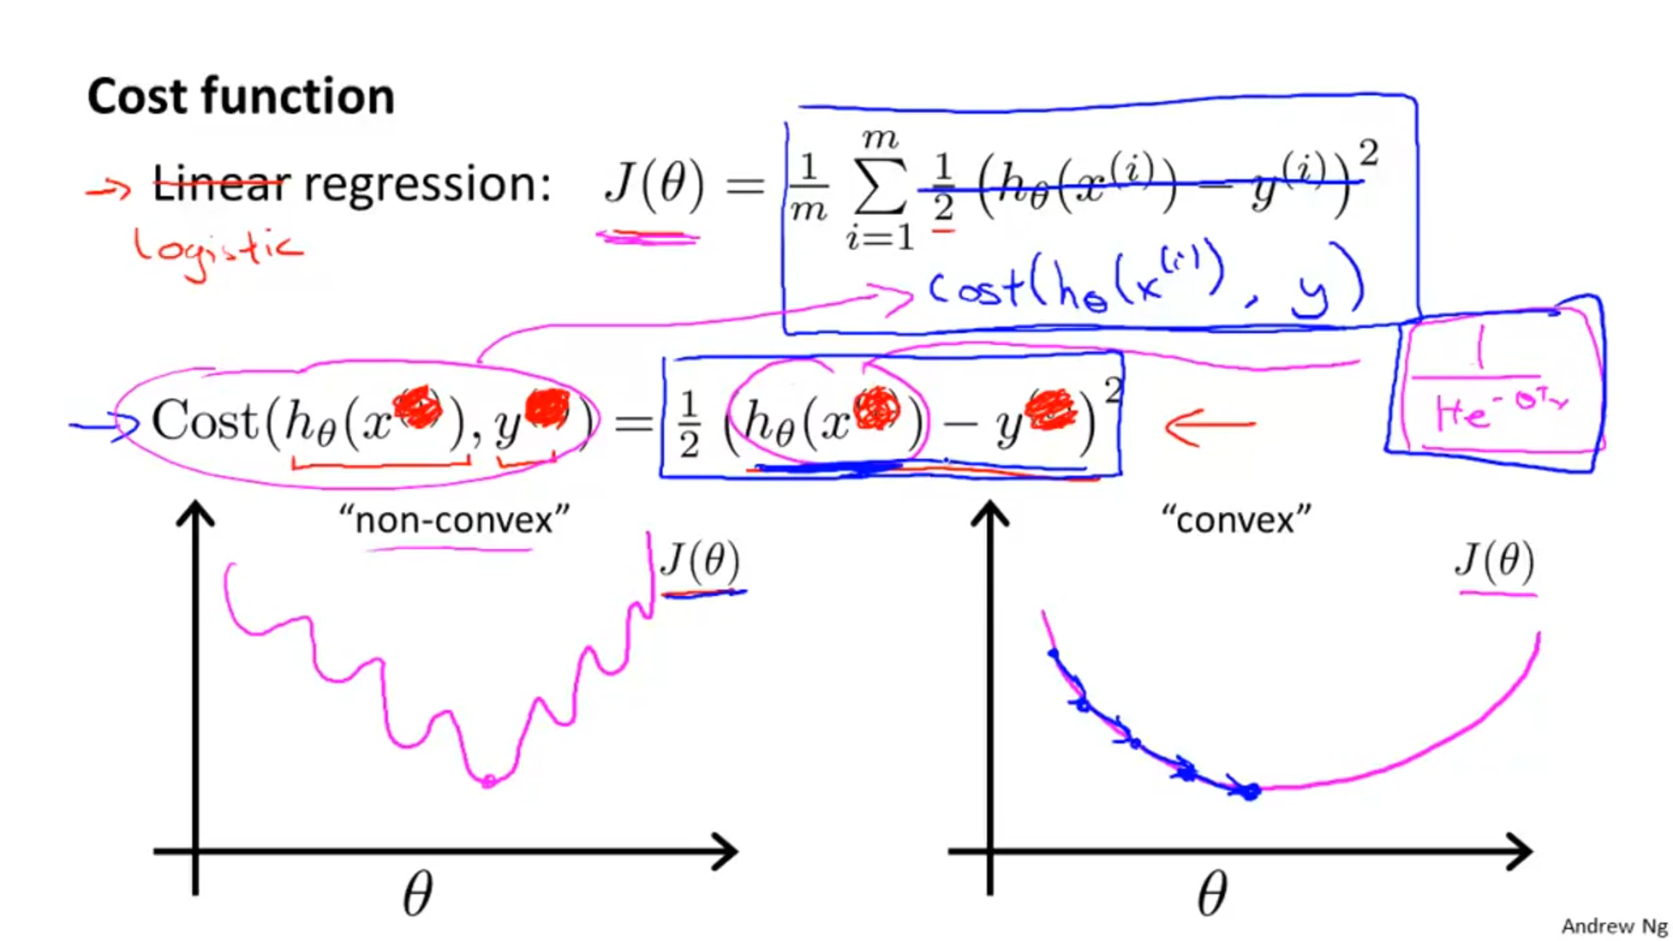



If we were to run gradient descent on this sort of function It is not guaranteed to converge to the global minimum.

**Actual cost function for logistic regression:**



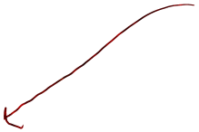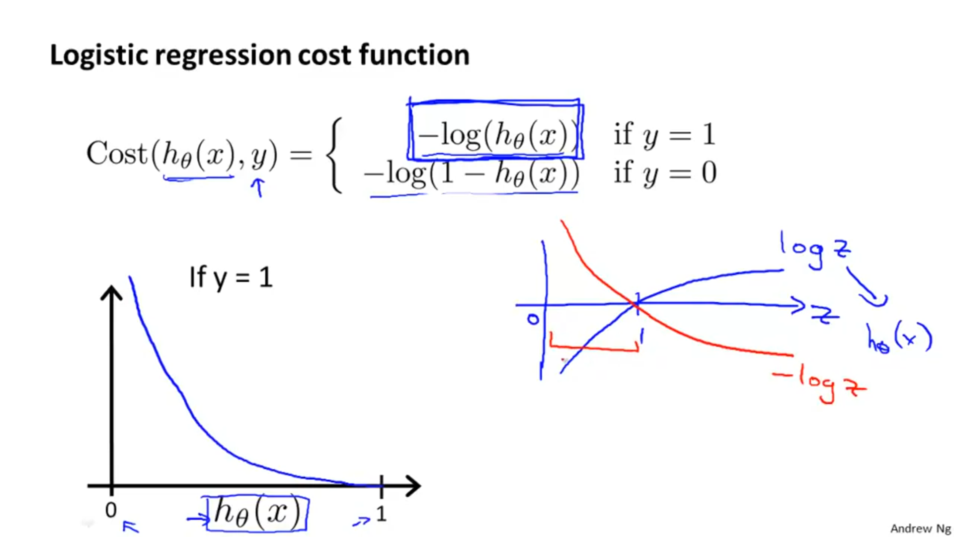



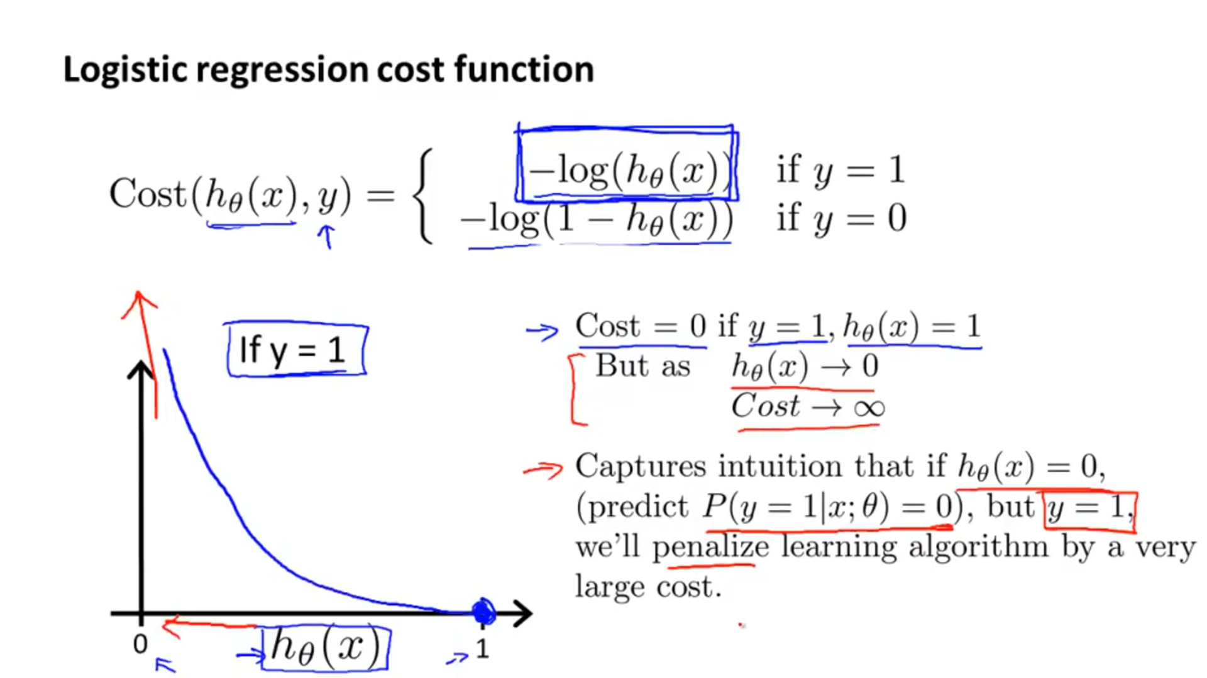

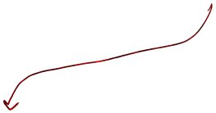

Say we predict that probability that a person has a malignant tumor is 0, that is, P(y=1|x; )=0 . However, the actual test results show that the person does have a tumor. In such a case, where our prediction is completely wrong, we penalize our cost function by a very large amount.

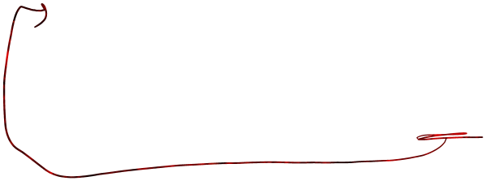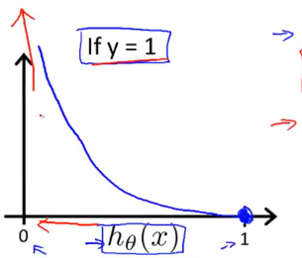

Say we predict that probability that a person has a malignant tumor is 0.8, that is, P(y=1| x; )=0.80. Now, the actual test results also show that the person does have a tumor. In such a case, where our prediction is 80% right, we penalize our cost function by a very less amount.

Plot for 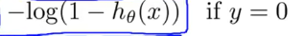



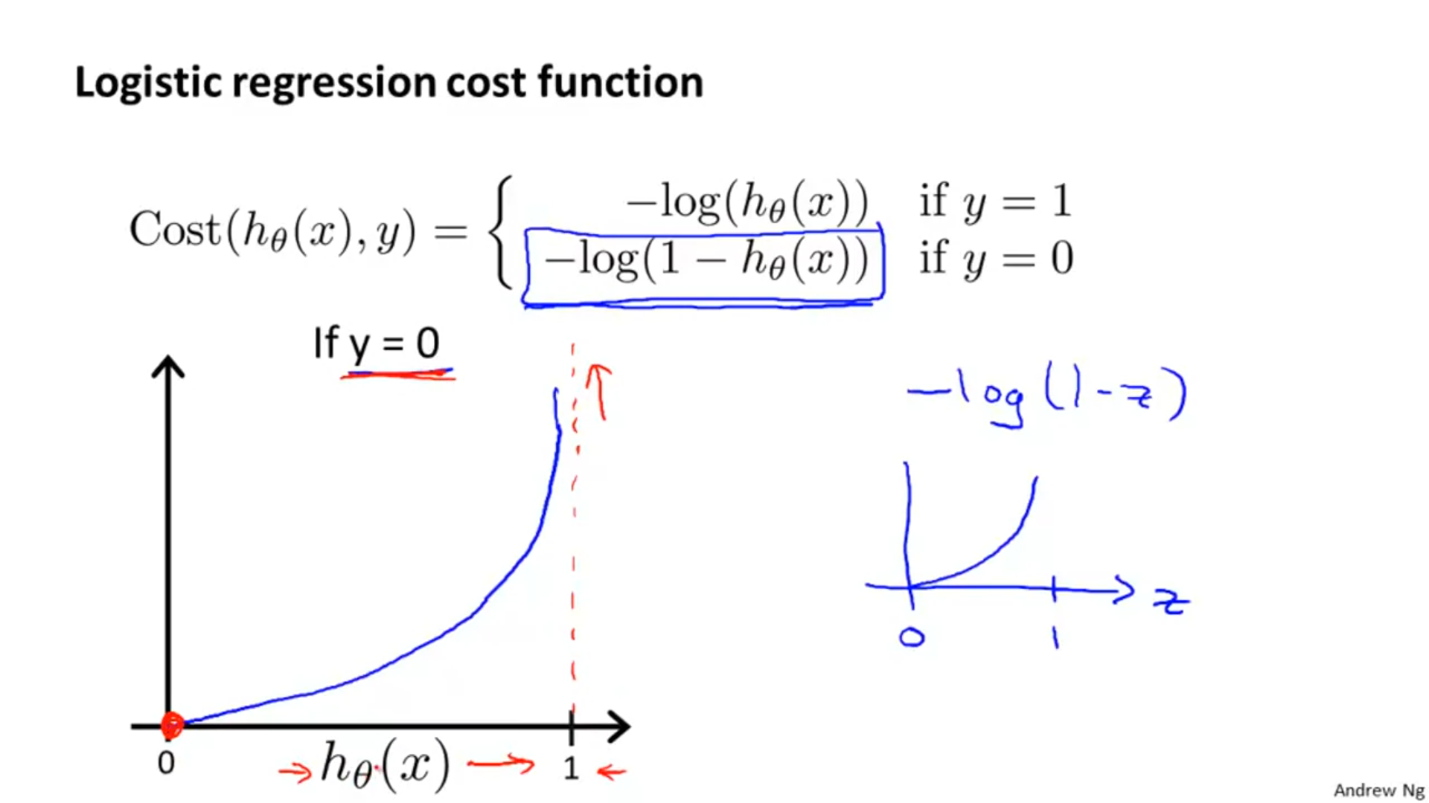

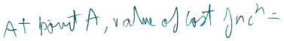Say we predict that probability that a person has a malignant tumor is 0, that is, P(y=0|x; )= 1 . The actual test results also show that the person does not have a tumor. In such a case, where our prediction is completely right, we do not penalize our cost function at all.

## NOTE: In both the graphs above , h tells us the probability that we predicted an outcome to be 0 and 1 . If plot a curve of -log(thetax) i.e. y=1 and predict probability y=1 to be 0.9 , then our prediction is quite right and value of cost function very less.

QUESTION:

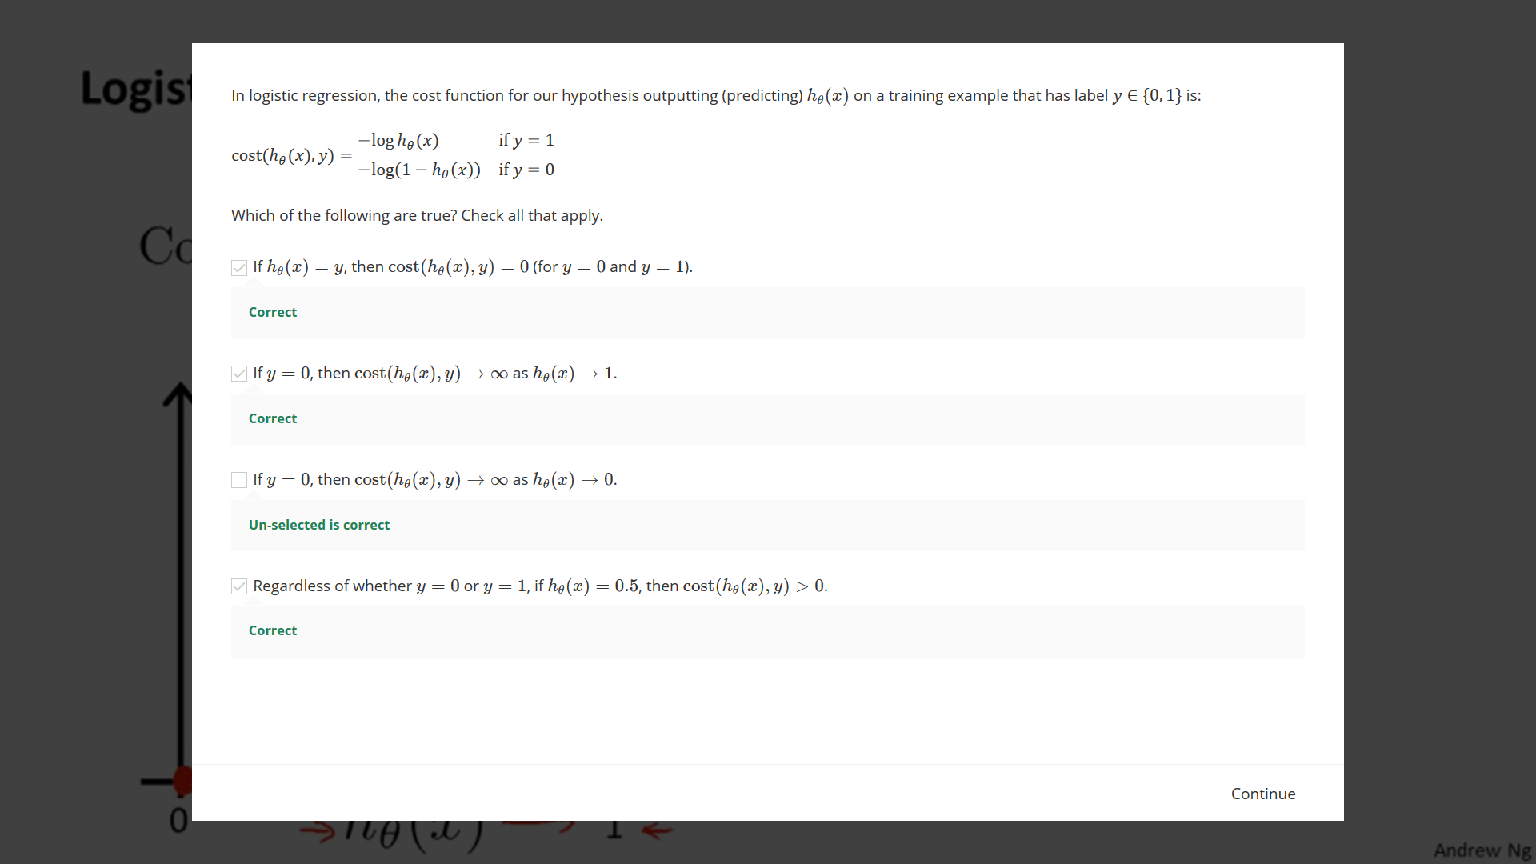

Other way of writing the cost function:



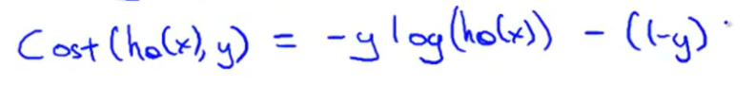

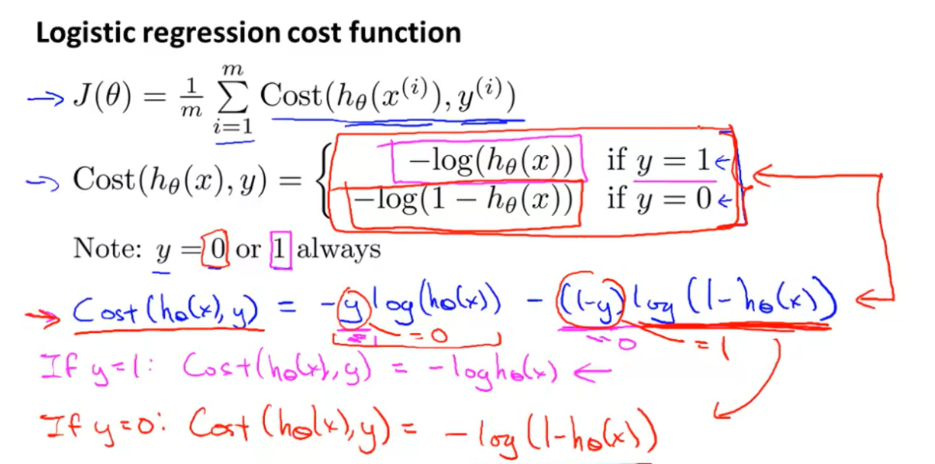

Final Cost function:



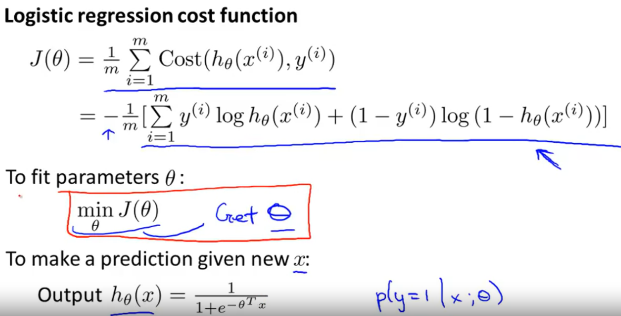



This output gives the probability of getting 1 given x and a parameter theta corresponding to it.



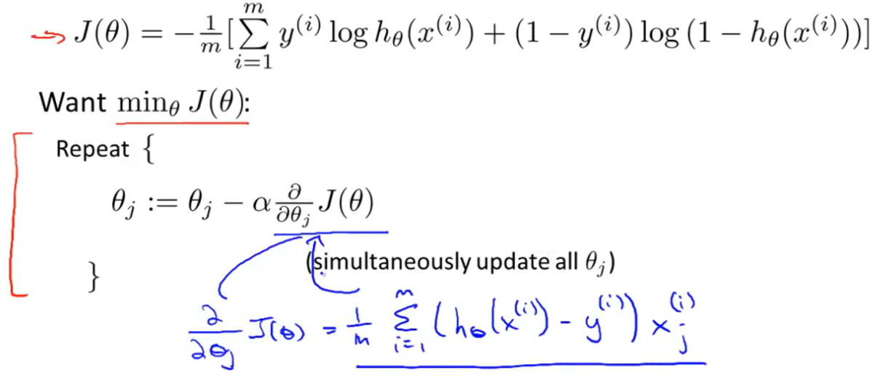

After doing derivative of this we get this .

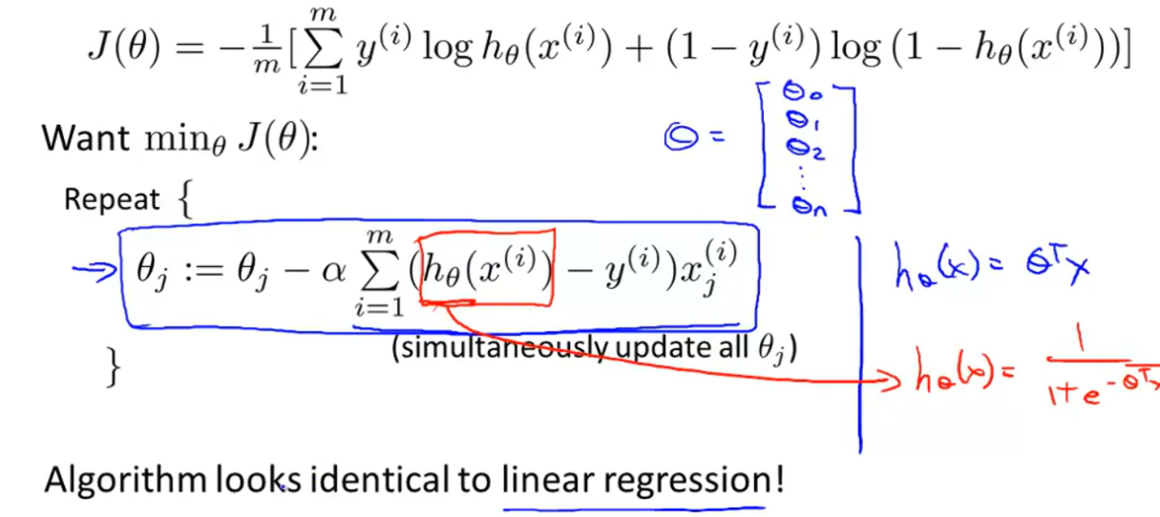

Questions:

Q1: 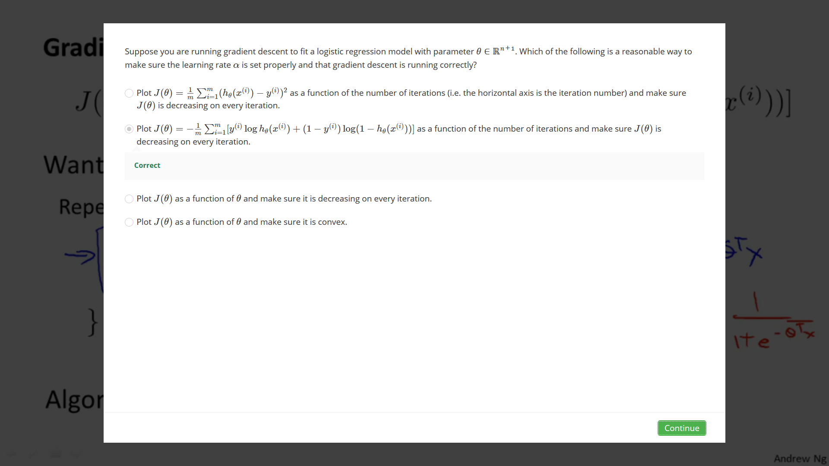

Q2: 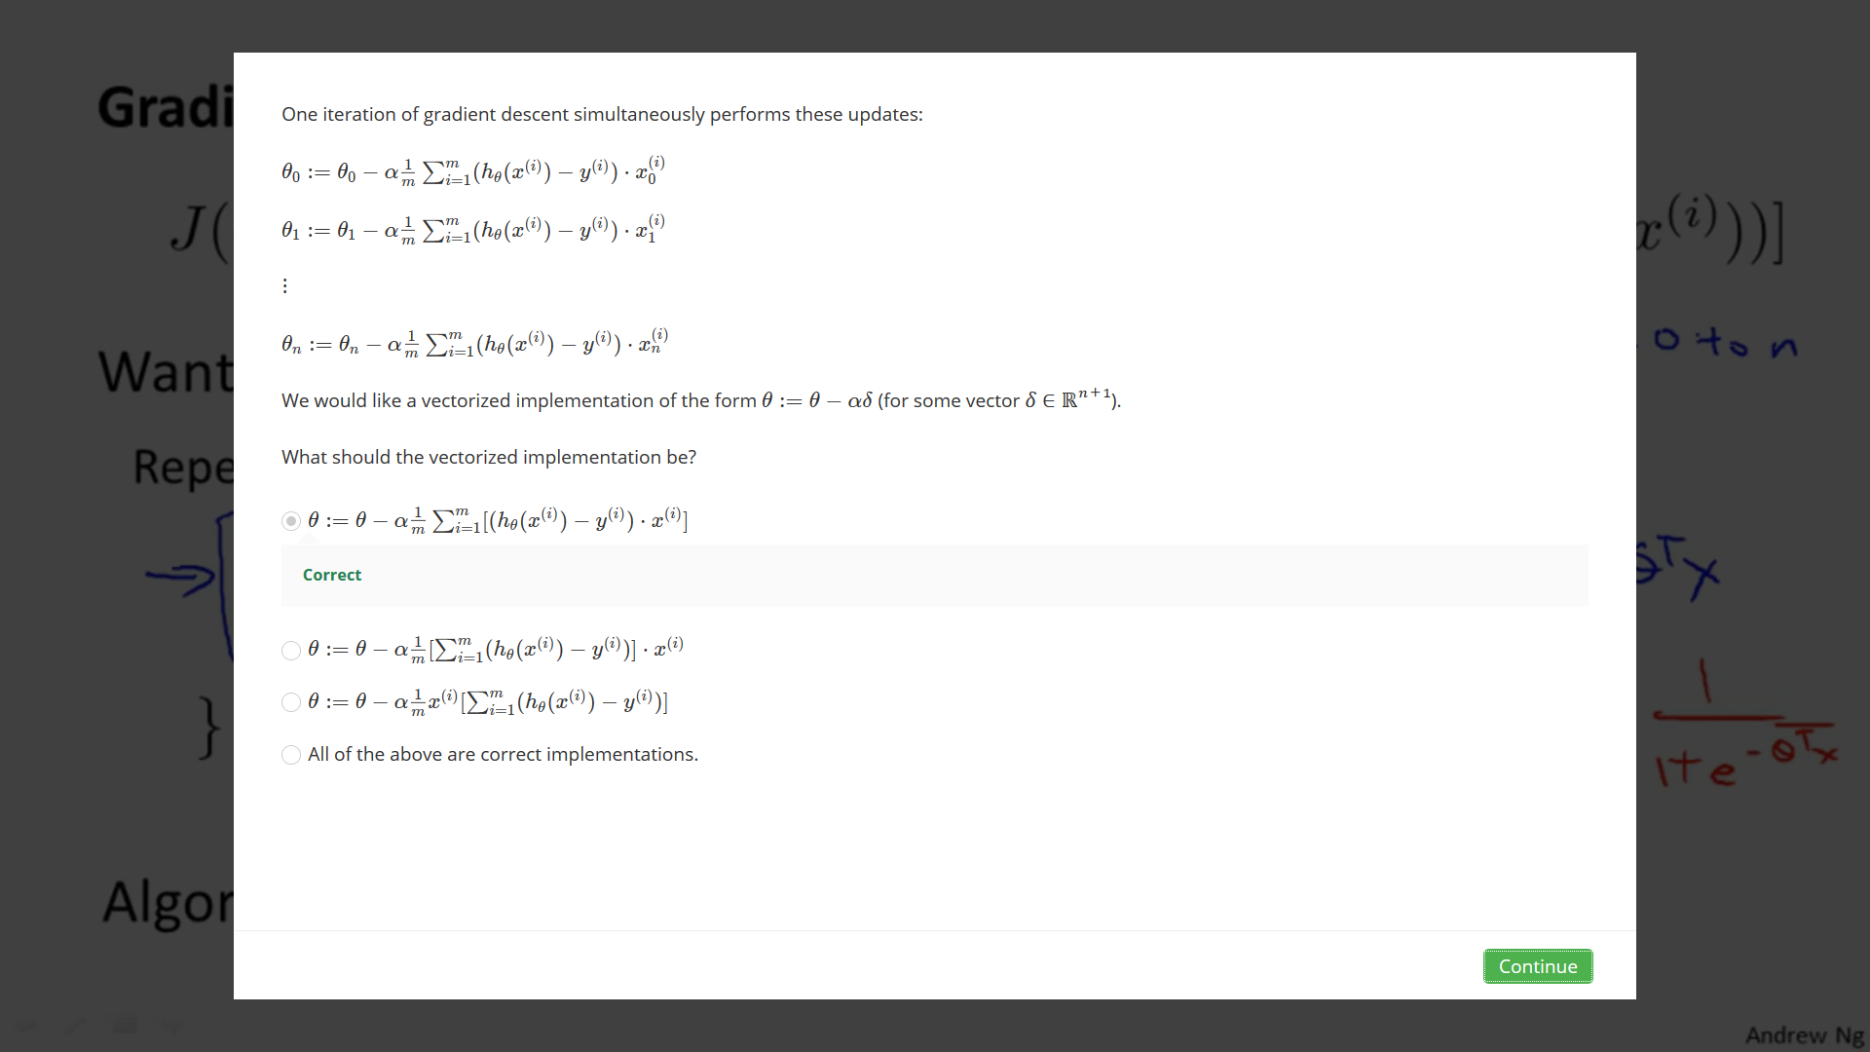

Multiclass Classification: One – vs- all classification



In this topic , we try to classify multivariate data , i.e. when we have to classify data into 3 or more types.

Say we have to classify a weather as : Sunny , Cloudy or Rainy



Here we represent these weather



types by :-

Binary classification vs Multi-class classification:

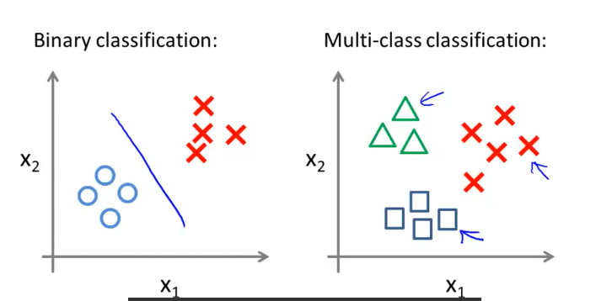

Using the one vs all method:

We turn above multi-class classification problem into three separate two class classification problems.

So let's start with class one which is the triangle. We're going to essentially create a new sort of fake training set where classes two and three get assigned to the negative class. And class one gets assigned to the positive class. You want to create a new training set like that shown on the right, and we're going to fit a classifier which I'm going to call h subscript theta superscript one of x where here the triangles are the positive examples and the circles are the negative examples. So think of the triangles being assigned the value of one and

the circles and squares assigned the value of zero. And we're just going to train a standard logistic regression classifier and maybe that will give us a position boundary that looks like this:

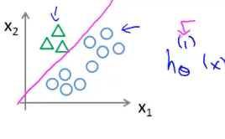

We do the same for squares and crosses and obtain the following diagram:

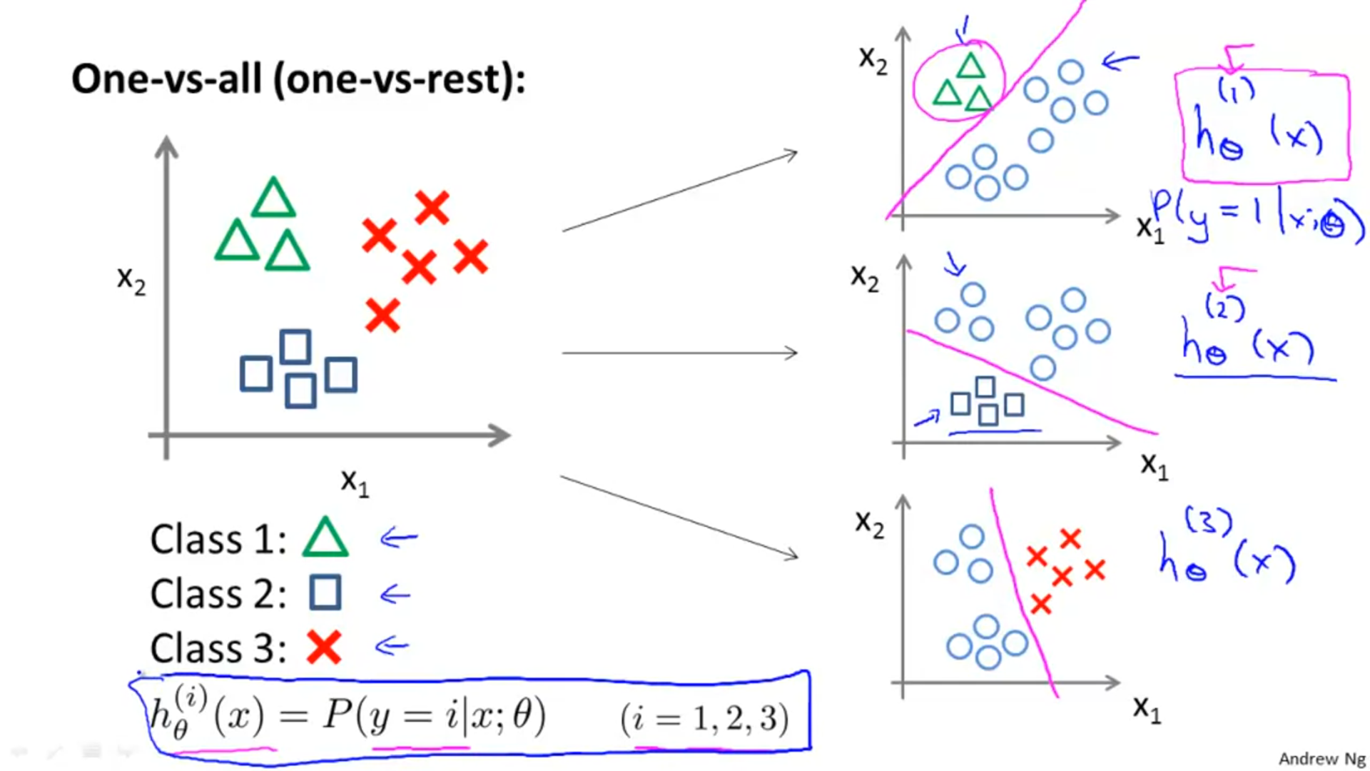



This equation represents that we now have three classifiers, each of which was trained to recognize one of the three classes.

Summarising one-vs-all method:

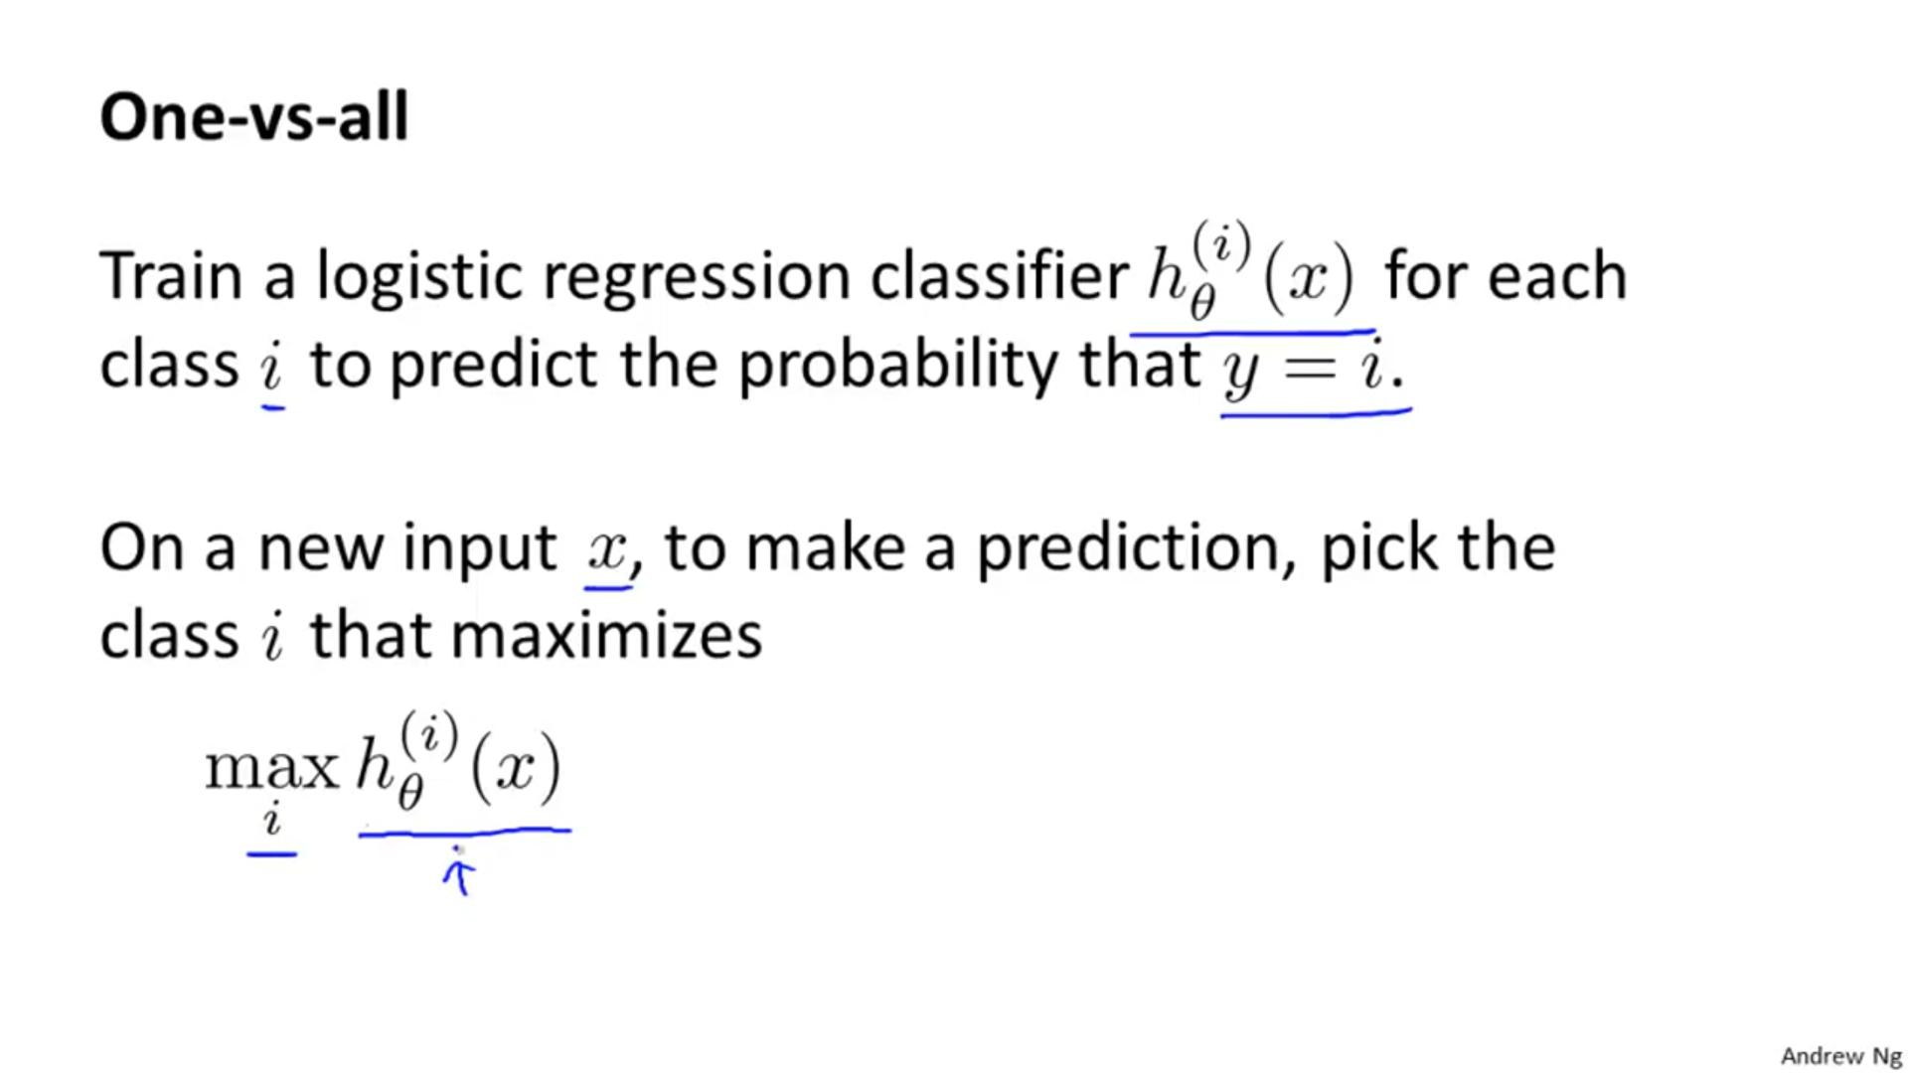 This means that when we're given a new input x, and want to make a prediction, what we do is we just run all of our classifiers on the input x and we then pick the class i that maximizes the three. So, we just basically pick the classifier, which is the most confident. So whichever value of i gives us the highest probability we then predict y to be that value.

